x

|  |  |
| --- | --- |
| **Ex. No: 9** | **Exploring Containerization & Application Deployment with Docker** |
| **23.10.2024** |

**Aim:**

To create and deploy a simple web server using Docker, hosting an Apache HTTP server with a basic HTML file.

**Procedure:**

1. Install Docker

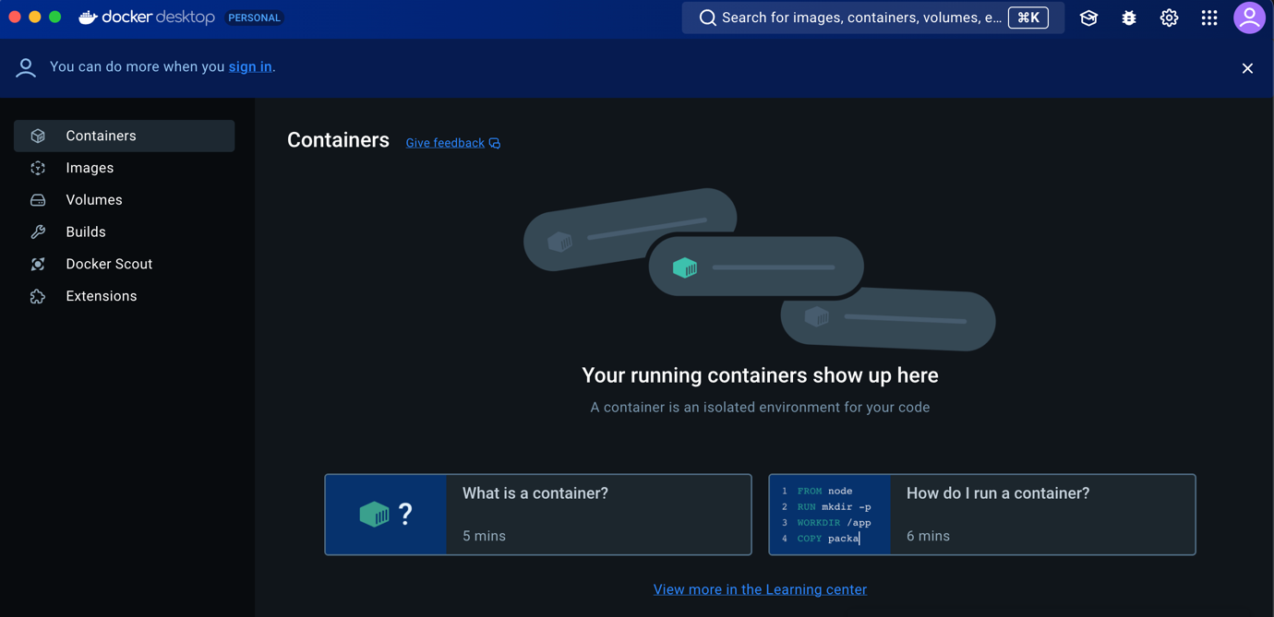

1. Create a Simple HTML Page

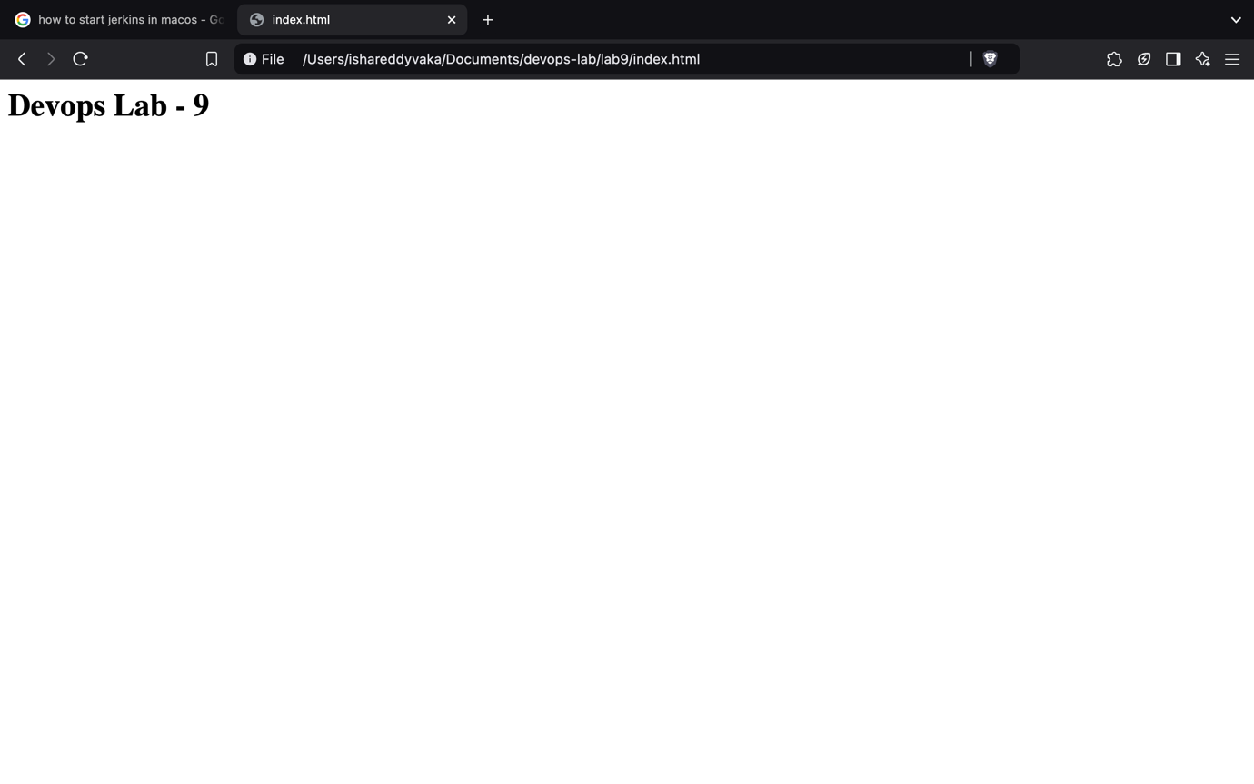

1. Create a Dockerfile

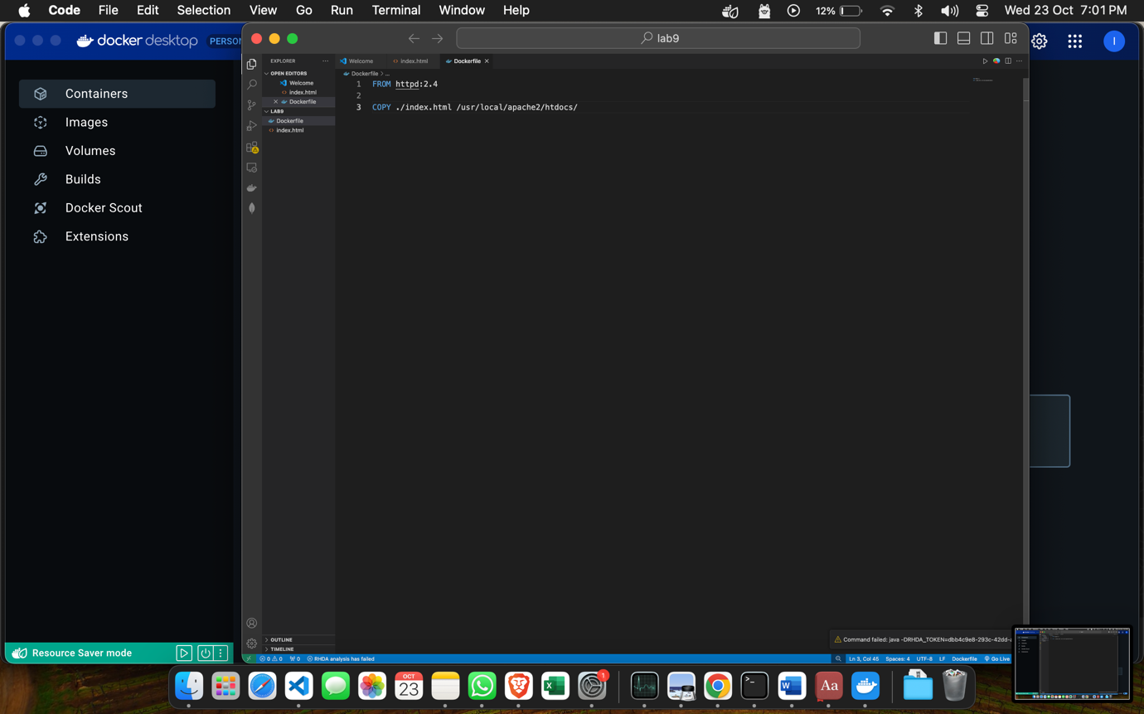

1. Build the Docker Image

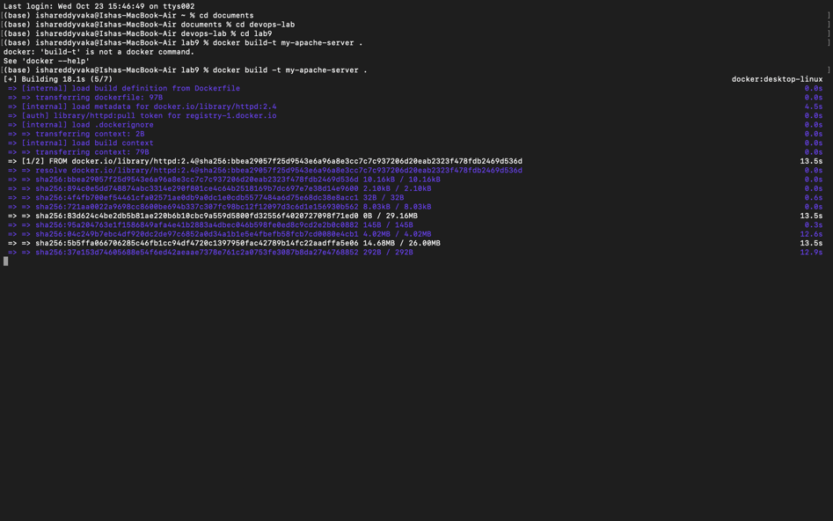

1. Run the Docker Container

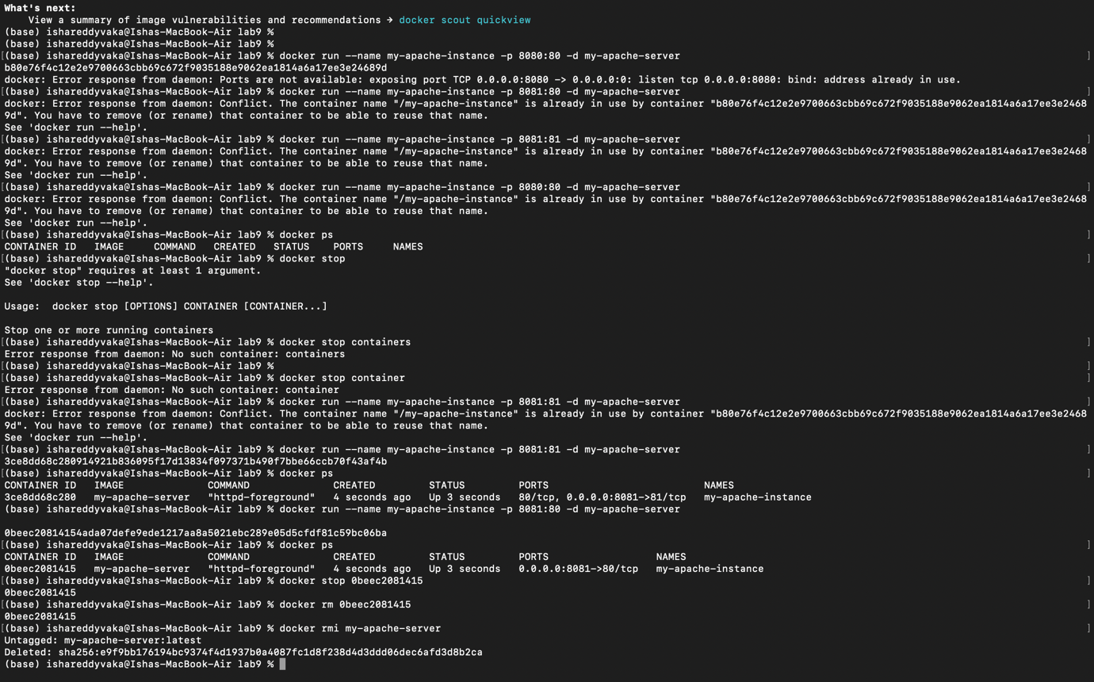

1. Access the Apache web server

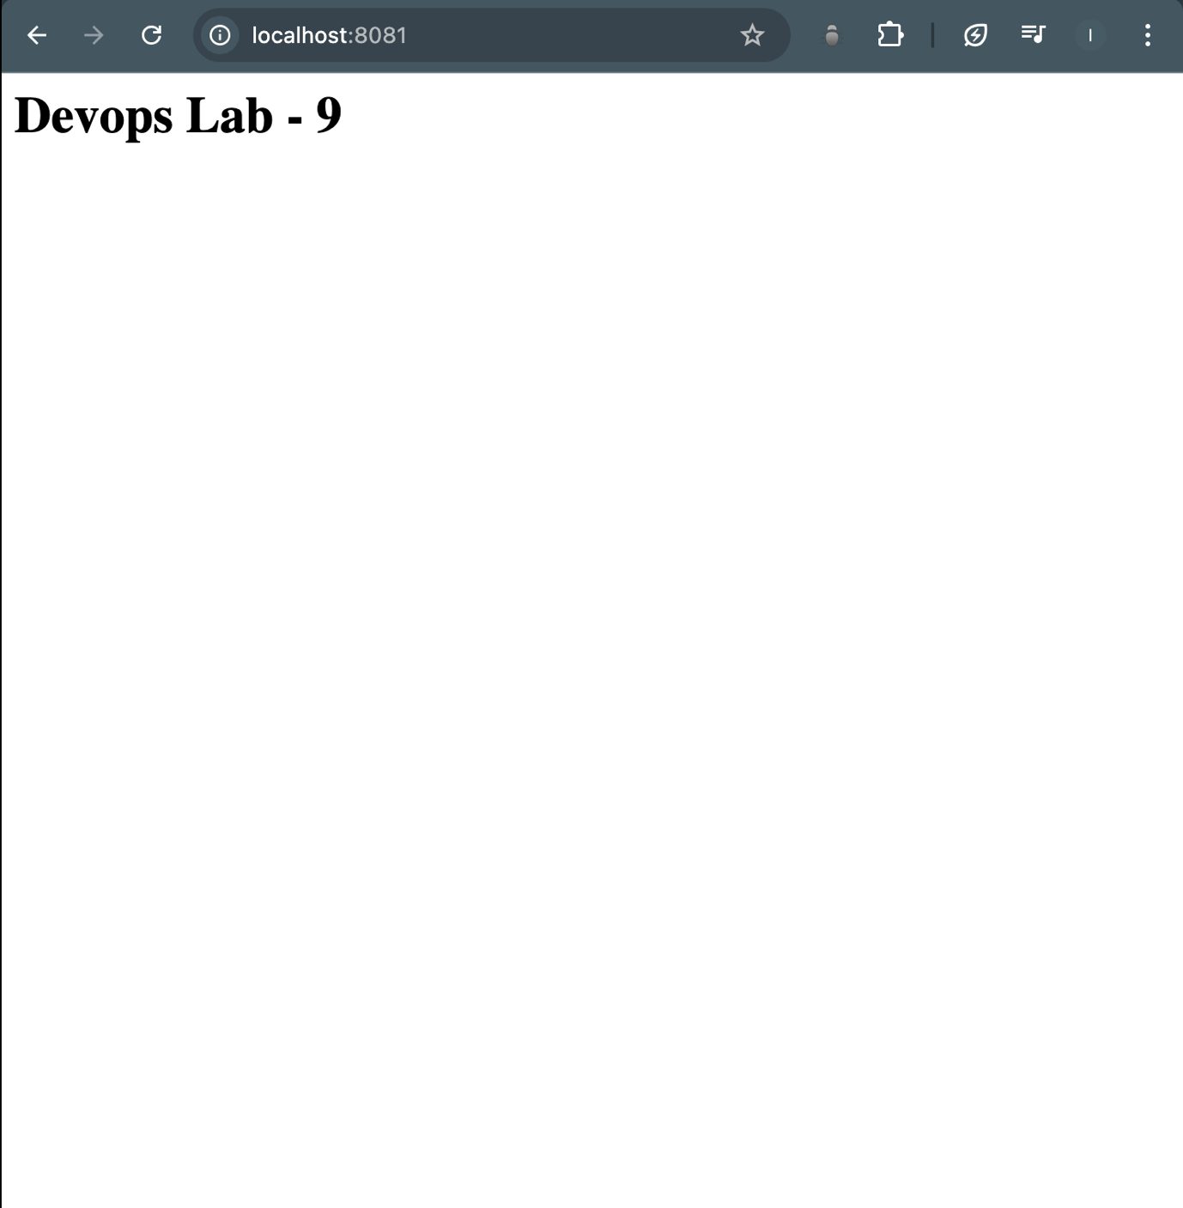

1. Clean up



**Result:**

Therefore, we've successfully containerized and deployed a Docker container running an Apache HTTP server with an index.html file.